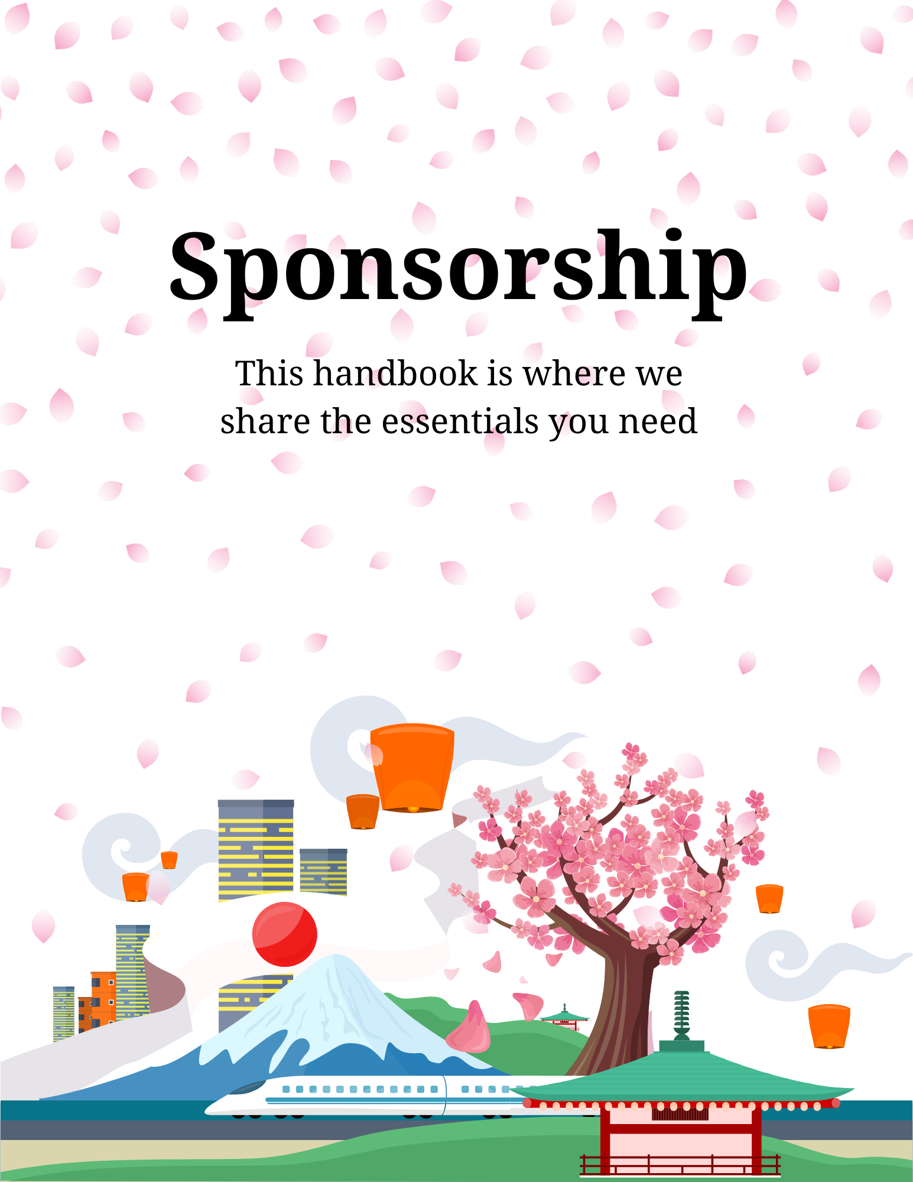
Sponsorship Guide for Yokota Air Base

Chapter 1: Introduction to Sponsorship
1.1 Overview of sponsorship at Yokota Air Base
1.2 Importance of sponsorship in military readiness
1.3 Goals and benefits of the sponsorship program

Chapter 2: Sponsorship Training
2.1 Training requirements for new and returning sponsors
2.2 eSAT (Electronic Sponsorship Application & Training) overview
2.3 Face-to-face training specifics at the Military & Family Readiness Center

Chapter 3: Roles and Responsibilities
3.1 Detailed roles of the sponsor before, during, and after the arrival of the sponsored member
3.1.1 Initial Contact
3.2 Roles During Arrival
3.3 Responsibilities After Newcomer’s Arrival
3.4 Supporting the Spouse and Family

Chapter 4: Pre-Arrival Planning
4.1 Steps for effective pre-arrival coordination
4.2 Housing and transportation arrangements
4.3 Financial advice and government travel card (GTC) handling
4.4 Childcare, schooling, and other family services setup
4.5 Handling special circumstances (e.g., pets, married en route)

Chapter 5: Arrival and Post-Arrival Procedures
5.1 Initial steps upon arrival at Yokota Air Base
5.2 In-Processing Assistance
5.3 Ensuring Essential Services are Available
5.4 Integrating into the Community
Chapter 6: Building Connections and Community Integration
6.1 Introducing newcomers to local facilities and services
6.2 Encouraging Involvement in Community and Base Events
6.3 Cultural Adaptation and Tips for Living in Japan
6.4 Support for Spouses and Family Members

Chapter 7: Resources for Sponsors
7.1 Detailed contact list and support services available at Yokota Air Base

Chapter 8: Glossary of References and Supporting Information
8.1 References
8.2 Acronyms and Abbreviations

Chapter 1: Introduction to Sponsorship

1.1 Overview of sponsorship at Yokota Air Base
Sponsorship at Yokota Air Base is a vital component of the military transition and relocation process. As the initial point of contact for newcomers, sponsors play an essential role in facilitating a smooth integration into both the military unit and the local community. The sponsorship program at Yokota is designed to support service members and their families as they transition to a new environment, helping to minimize the stress of relocating and maximizing their readiness and well-being.

1.2 Importance of Sponsorship in Military Readiness
Effective sponsorship is crucial for maintaining high morale and readiness within the unit. By providing timely and accurate information, as well as personal support, sponsors ensure that incoming personnel are prepared and well-equipped to begin their assignments promptly and efficiently. The support offered by sponsors extends beyond simple logistics; it encompasses the well-being of the entire family, addressing educational, social, and emotional needs that contribute to the overall success of the military mission.

1.3 Goals and Benefits of the Sponsorship Program
The primary goal of the sponsorship program is to create a welcoming and supportive environment that aids in the rapid adjustment of newcomers to Yokota Air Base. This goal is achieved through several key objectives:
- Enhancing Communication: Sponsors serve as the main communication link between the incoming personnel and the base’s facilities and services. They provide critical information about the base, local community, housing, schooling, and other essential services
- Facilitating Community Integration: Sponsors help integrate service members and their families into the base and local community by connecting them with resources that align with their specific needs and interests, such as local clubs, community groups, and educational programs
- Increasing Unit Cohesion: By assisting newcomers in settling in and adjusting to their new roles, sponsors directly contribute to the operational readiness and cohesion of their units. A well-supported newcomer is quicker to acclimate and can contribute to mission objectives more effectively
- Supporting Family Stability: For military families, moving can be a disruptive experience. Sponsors play a critical role in ensuring that families receive the support they need, from educational resources for children to employment opportunities for spouses, thereby fostering a stable and supportive environment for all family members

Chapter 2: Sponsorship Training

2.1 Training Requirements for Sponsors
Sponsorship at Yokota Air Base is a role that comes with specific training requirements to ensure sponsors are fully equipped to assist newcomers. According to Department of the Air Force Instruction (DAFI) 36-3009, all first-time sponsors and those who have not participated in sponsorship duties within the past year must complete the mandatory training. This training ensures that all sponsors are familiar with the latest policies, procedures, and resources essential for fulfilling their responsibilities effectively.

2.2 eSAT (Electronic Sponsorship Application & Training) Overview
The Electronic Sponsorship Application and Training (eSAT) is an essential tool for sponsors at Yokota Air Base. It provides comprehensive online training that covers all aspects of the sponsorship process, from initial contact with newcomers to their integration into the base community. The eSAT platform offers:
- Detailed Role and Responsibilities Guides: Sponsors can access information outlining their duties throughout the different phases of the relocation process
- Customizable Resources: Includes checklists, templates for welcome letters and emails, and other personalized tools to aid in communication with incoming personnel
- Certification Process: Upon completion of the eSAT program, sponsors receive a certificate, which they must forward to the Relocation Manager and their Command Support Staff (CSS) to verify their training status.

2.3 Face-to-Face Training at the Military & Family Readiness Center
In addition to the online eSAT, Yokota Air Base provides face-to-face training sessions hosted by the Military & Family Readiness Center. These sessions are designed to give sponsors a deeper understanding of the specific challenges and opportunities at Yokota. Key components of this training include:
- Local Installation Information: Detailed insights into Yokota-specific procedures and resources, crucial for assisting newcomers in navigating their new environment
- Interactive Role-Playing and Scenarios: Practical exercises that simulate common situations sponsors may encounter, enhancing their problem-solving and communication skills
- Community and Network Building: Opportunities to connect with other sponsors, share experiences, and build a support network that enhances the overall effectiveness of the sponsorship program

Chapter 3: Roles and Responsibilities

3.1 Detailed Roles of the Sponsor Before Arrival
The role of a sponsor begins as soon as they are assigned an inbound member and family. Before the arrival of the newcomers, sponsors are expected to engage in proactive communication and preparation to ensure a smooth transition. Key responsibilities include:

3.1.1 Initial Contact
The initial contact phase is critical in establishing a welcoming and informative communication channel between the sponsor and the inbound members. Sponsors should reach out to the newcomers as soon as possible after being assigned, ideally within two days. This contact sets the tone for the relocation process and builds a foundation of trust and support. Key aspects of the initial contact include:
  - Establishing Communication Channels: Sponsors should provide multiple means of communication, such as email, phone, and messaging apps, to ensure that the inbound member can reach out conveniently and reliably. This includes setting up a primary and a backup communication method to handle any unforeseen issues effectively
  - Inclusive Communication: It is essential that communication is not only with the service member but also includes their spouse, if applicable. This approach ensures that the entire family feels supported and recognized. The spouse should be encouraged to participate in conversations, ask questions, and express any specific concerns or needs they might have regarding the relocation
  - Information Sharing: During the initial contact, sponsors should provide an overview of the relocation process, including what the newcomers can expect in the coming weeks. This information should be comprehensive, covering key topics such as travel, housing, schooling for children, and any community-specific details that would be relevant to the family

- Needs Assessment: Conduct a detailed assessment to understand the specific needs of the newcomer and their family, including considerations for spouses, children, EFMP (Exceptional Family Member Program) requirements, and pets.
- Information Sharing: Provide comprehensive information about the base, local community, housing, schools, and medical facilities, tailored to the needs identified in the assessment.
- Travel and Lodging Arrangements: Assist in planning travel logistics, including airport pickup and lodging reservations, ensuring that accommodations are ready upon arrival.

3.2 Roles During Arrival
Upon the arrival of the newcomers, the sponsor's role shifts to hands-on assistance and guidance through the initial days and weeks at Yokota Air Base:
- Welcome and Orientation: Meet the newcomers upon arrival, offer a warm welcome, and provide an initial tour of the base
- In-Processing Assistance: Guide the newcomers through the in-processing procedures, helping them navigate the various administrative offices and requirements
- Settling In: Help arrange essentials such as commissary access, local transportation, and temporary accommodations, ensuring the newcomers feel settled and supported

3.3 Responsibilities After Newcomer’s Arrival
The sponsor’s support continues well after the initial arrival, as they help integrate the newcomer into the Yokota community:
- Ongoing Communication: Maintain regular contact with the newcomers, offering support and guidance as they adjust to their new environment
- Community Integration: Introduce newcomers to key facilities, social events, and community groups to help them establish social connections and integrate into the local culture
- Problem Resolution: Serve as a point of contact for any issues or challenges the newcomers face, providing solutions or directing them to the appropriate resources

3.4 Supporting the Spouse and Family
Recognizing the significant impact of relocation on military families, sponsors also focus on supporting the spouse and family members:
- Spouse Employment and Education: Provide information on employment opportunities and educational resources available for spouses, including the Military Spouse Employment Partnership (MSEP) and educational programs
- Family Services: Connect the family with various support services as they apply, such as the Military & Family Readiness Center (M&FRC), school liaison office, and the Exceptional Family Member Program
- Youth Programs: Inform about and facilitate connections to youth sponsorship programs and activities that can help children adjust to their new school and social environment

Chapter 4: Pre-Arrival Planning

4.1 Steps for Effective Pre-Arrival Coordination
Effective pre-arrival planning is crucial to ensure that the transition for the inbound member and their family is as smooth as possible. Sponsors play a key role in coordinating various aspects of the newcomer's arrival at Yokota Air Base. These steps include:
- Detailed Itinerary Planning: Provide the newcomers with a detailed itinerary that includes dates, times, and locations for all key events and appointments upon their arrival. This should cover everything from airport pickup to initial briefings at the base.
- Communication of Expectations: Clearly communicate what the newcomers should expect in their first days at the base, including the schedule for in-processing and any immediate duties or responsibilities
- Advance Preparation: Ensure that all necessary paperwork and arrangements are prepared in advance, such as school registrations for children, lodging reservations, and any necessary medical appointments, 374 AW-Form 50 (Signed by Unit and submitted to SF prior the week of arrival and attending Drivers Course), Post office Mailbox set up etc.

4.2 Housing and Transportation Arrangements
Securing housing and transportation are two of the most critical components of pre-arrival planning:
- Housing Arrangements: Assist in securing appropriate lodging for the newcomers, whether temporary or permanent. This includes making reservations at the Kanto Lodge or helping with applications for on-base housing or off-base rentals, depending on the family’s preference and availability
  - If the member is E-6 and below and unaccompanied, the sponsor will need to check with the Area Dorm Leader (ADL) for dorm room availability.
- Transportation Logistics: Organize transportation from the airport to Yokota Air Base or plan to meet newcomers at the PAX terminal and ensure that the newcomers have reliable transportation for their initial days on the base, especially for in-processing and essential errands. If the sponsor is not available to drive them for various appointments, ensure the base shuttle information is available.

4.3 Financial Advice and Government Travel Card (GTC) Handling
Financial preparations are a significant aspect of the relocation process:
- Government Travel Card Guidance: Advise the inbound member on the use of the Government Travel Card (GTC), reminding them to use it responsibly and to have member place their GTC in mission critical status to avoid late fees.
- Advance Pay and Allowances: Inform the member to seek information from Finance regarding the eligibility/possibility of advance pay and allowances which can be critical for covering initial expenses such as housing deposits and essential purchases upon arrival

4.4 Childcare, Schooling, and Other Family Services Setup
Ensuring that family services are arranged before arrival can significantly ease the family’s transition:
- School and Childcare Arrangements: Help coordinate school registrations and childcare services, such as the Yume Child Development Center, requesting spots be secured (this depends on Yume’s availability) based on the family's arrival schedule
- Family Support Services: Introduce the family to the Military & Family Readiness Center and other support services available at the base, which offer programs and assistance tailored to Airmen and families

4.5 Handling Special Circumstances
Special circumstances such as traveling with pets or specific medical needs require additional attention:
- Pet Travel and Accommodations: Provide information and support for pet travel, including quarantine requirements, pet-friendly lodging, and veterinary services
- Special Medical or Educational Needs: Assist families with members enrolled in the Exceptional Family Member Program (EFMP) by connecting them with necessary medical and educational services at the base and in the local community
- Marriage En Route: Notification and Documentation: Advise the inbound member to inform their losing Military Personnel Flight (MPF) and First Sergeant about their marriage plans en route. (Marriage en route is discouraged as the process for below action items are lengthy) This is crucial for ensuring all necessary administrative processes are handled correctly.
  - Command Sponsorship: Assist the member in understanding the importance of obtaining command sponsorship for their spouse. This includes helping them gather and submit all required documentation to ensure their spouse receives all entitled benefits and travel reimbursements.
  - Medical and Housing Arrangements: Guide the member through the process of enrolling their spouse in medical programs and adjusting housing arrangements to accommodate their new family status. This might involve coordinating with medical and housing offices on base to ensure smooth transitions and updates.

Chapter 5: Arrival and Post-Arrival Procedures

5.1 Initial Steps Upon Arrival at Yokota Air Base
The sponsor's role becomes more hands-on upon the arrival of the newcomers. This phase is critical in setting a positive first impression and providing immediate support:
- Airport Reception: If member arrives to the Yokota PAX Terminal, meet the newcomers at the airport to welcome them personally. This gesture helps to alleviate any initial stress and provides a friendly face upon arrival. If the sponsor is unable to meet the newcomer at a commercial airport, ensure that shuttle times through FSS Vehicle Operations have been provided to make transportation smooth and stress free.
- Lodging Check-In: Assist the newcomers with check-in procedures at their lodging, whether it’s at the Kanto Lodge or other accommodations, and ensure that they are comfortable and have everything they need for their first night
Assisting with lodging check-in is a critical step in helping newcomers feel settled from the moment they arrive:
  - Check-In Assistance: Help the newcomers with check-in procedures at their assigned lodging, ensuring they understand all amenities and policies. Accompany them to their room or lodging area to make sure everything is in order and meets their expectations
  - Usage of Click2Go and Exchange Apps: Introduce and assist the newcomers in using the Click2Go (Commissary) and The Exchange apps, which are essential tools for securing groceries and household items. These services allow for convenient pre-ordering and pickup, which can significantly ease the transition by ensuring that basic necessities are readily available upon arrival
  - Pre-Ordered Item Coordination: Ensure that any items the newcomers have pre-ordered through Click2Go or The Exchange are ready and waiting in their lodging. If they have placed orders for pickup, coordinate the collection and delivery of these items to their temporary accommodation. This step is especially helpful for families arriving after long flights who may need immediate access to food and personal care products without the need to shop right away

5.2 In-Processing Assistance
The first few days at Yokota Air Base involve a series of in-processing activities that are essential for the newcomers to become fully integrated into the base operations:

- Ensure newcomers who will not be residing in the dorms see the Housing office within 2 business days of arrival
- Register members for Newcomer’s Orientation at the Military & Readiness Family Center which is held every Wednesday.
- Register members submit the 374 AW Form 50 to Pass & Registration at Security Forces no later than the week prior to the scheduled Driver’s Education course to register participants.0
- .
- Base Orientation: Guide the newcomers through a comprehensive orientation of the base. This includes introducing them to key facilities such as the commissary, BX, medical clinic, and family support centers.
- In-Processing Appointments: Accompany them to important in-processing appointments. These include visits to the personnel office, finance for travel voucher submissions, and any other required administrative offices.
- Introduction to Unit: Arrange a meeting with their new unit and direct supervisor. This introduction is vital for setting work expectations and integrating them into their team.

5.3 Ensuring Essential Services are Available
Making sure that all essential services are accessible to the newcomers is a priority in the first days after arrival:
- Basic Necessities: Ensure that the newcomers have access to essential items such as food, basic household supplies, and any immediate personal items they may need.
- Communication Setup: Assist them in setting up necessary communication services, such as mobile phones and internet, which are crucial for staying connected both on and off base.
- Transportation Needs: Help them understand the transportation options available on base and in the local area, including shuttle services, car rental facilities, and public transportation.

5.4 Integrating into the Community
After the initial logistical needs are met, focus shifts to helping the newcomers integrate into the community:
- Community Events and Groups: Introduce them to community events, clubs, and social groups that can help them make connections and build friendships
- Cultural Orientation: Provide resources and opportunities to learn about Japanese culture and customs, which is particularly important for those stationed overseas for the first time
- Spouse and Family Support: Ensure that spouses and family members are aware of and feel included in community activities, spouse clubs, and employment and volunteer opportunities

Chapter 6: Building Connections and Community Integration

6.1 Introducing Newcomers to Local Facilities and Services
Helping newcomers familiarize themselves with Yokota Air Base and the surrounding community is essential for their successful integration:
- Facility Tours: Organize tours of key facilities on base, such as the community center, fitness centers, medical clinic, schools, and family support centers. These tours help newcomers understand where they can find essential services and how to access them, Spouses are encouraged to sign up for “Heartlink on the Road”
A

6.2 Encouraging Involvement in Community and Base Events
Active participation in community and base events can significantly enhance the newcomers' sense of belonging:
- Event Calendar: Provide the Samurai Scroll on the USAF Connect app with a calendar of upcoming events, emphasizing those especially welcoming to newcomers—such as social mixers, cultural nights, and family-friendly activities.
- Volunteer Opportunities: Introduce newcomers if interested to volunteer opportunities that can help them meet people, learn new skills, and integrate into the community. This might include volunteering at the base hospital, schools, or with local charitable organizations

6.3 Cultural Adaptation and Tips for Living in Japan
Living in a foreign country can be challenging; providing newcomers with resources and advice for adapting to Japanese culture is crucial:
- Cultural Training: Offer workshops or classes on Japanese culture, language, etiquette, and customs. These can help newcomers navigate their new environment more effectively and avoid cultural misunderstandings
- Local Exploration Encouragement: Encourage newcomers to explore their local area. Organize group outings to nearby attractions, restaurants, and cultural sites. This not only helps them get to know Japan better but also builds camaraderie with other base members.
- Resource Guide: Provide a guidebook or digital resources that include tips on living in Japan, such as how to use public transportation, where to shop for specific items, and how to handle language barriers

6.4 Support for Spouses and Family Members
Ensuring that spouses and family members feel included and supported is key to the overall adjustment of the family:
- Spouse Clubs and Groups: Promote involvement in spouse clubs and other base groups tailored to family members. These clubs often provide a network of support and friendship, as well as practical advice tailored to the unique needs of military families
- Educational Support Services: Highlight educational resources and support services available for children and spouses, such as the school liaison office and continuing education programs. These services are vital for families to feel secure and supported in their educational pursuits

Chapter 7: Resources for Sponsors

7.1 Detailed contact list and support services available at Yokota Air Base
Sponsor
- ESAT Required annually: https://millifelearning.militaryonesource.mil/

Key Contacts
- Yokota Passport Office: DSN 225-8333, Email: 374FSS.FSPD.Passports@us.af.mil - For passport issues and information.
- Yokota Veterinary Treatment Facility:
  - Website: Veterinary Readiness Activity Japan
  - Phone: DSN (315) 225-4363, Email: YokotaABVTF@gmail.com - For pet import guidelines and veterinary care.
- AMC Travel Site for Pet Travel: AMC Pet Travel Page - For pet travel brochure and shipment information

Housing and Lodging
- Kanto Lodge Pet TLF/Lodging: DSN 224-2002, Email: 374fss.lodging@us.af.mil - For lodging reservations, including pet-friendly options.
- Dorm Manager: DSN Phone 81-425-52-2510; DSN (315) 225-8045, Email: 374ceshousing@us.af.mil - Contact for dormitory issues and information

4. Schools and Childcare
- Yokota West Elementary School: Yokota West ES
- Joan K. Mendel Elementary: Mendel ES
- Yokota Middle School: Yokota MS
- Yokota High School: Yokota HS
- Family Childcare PCS Care program: 374fss.fsyc.familychildcare@us.af.mil - For childcare services during PCS

Transportation and Vehicle Information
- Vehicle Operations: DSN 225.7720, Email: 374fss.fscvo@us.af.mil - For transportation arrangements upon arrival

Newcomers Information
- Yokota Official Newcomers Link: Yokota AB Newcomers Info - Official source for PCSing information

Additional Helpful Links
- Military OneSource: Military OneSource Website
- My Move: My Move Website

Post Office and Mailing
- Yokota’s Post Office: DSN 225-7220, Yokota Post Office - For post office services and mail forwarding arrangements

Shopping- Pre- Arrival
- The Exchange app https://play.google.com/store/apps/details?id=com.rjrt.Grizzly&pcampaignid=web_share
- Click2go (Commissary)
• Android: https://play.google.com/store/apps/details?id=com.commissaryclick2go.commissaryclick2go.googleplay&pcampaignid=web_share
• Apple: https://apps.apple.com/us/app/commissary-click2go/id1605807066

School Liaison- https://yokota374fss.com/schoolliaisonprogram/

M&FRC- https://yokota374fss.com/mfrc/

Security Forces Pass & Registration
- Driver’s license: Email: 374sfs.s5p@us.af.mil
- Passes: email: 374SFS.S5PR.PassRequest@us.af.mil
- DSN: 315-225-8333

Chapter 8 Glossary of References and Supporting Information
8.1 References
DAFI 36-3009, Military and Family Readiness Centers, 4 November 2022
AFI 36-2103, Individualized Newcomer Treatment and Orientation (INTRO) Program, 30 April 2012
AFD-150317-052, Driving in Japan, 20 June 2014
AFI 33-364, Individualized Newcomer Treatment and Orientation (INTRO) Program, 22 December 2006

8.2 Acronyms and Abbreviations
M&FRC – Military & Family Readiness Center
eSat- eSponsorship Application & Training
EFMP- Exceptional Family Member Program
MSEP- Military Spouse Employment Partnership
GTC- Government Travel Card
PCS- Permeant Change of Station
TLF- Temporary Lodging Expense
MPF- Military Personnel Flight
PAX- Persons/Passengers

Current as 9 July 2025

